

Considering states as Bars and profit as Length, Profit in the city New York is more.

Start-ups in the city New York is more.



Here , Profit is directly proportional to research and development.

So if profit increases or decreases research and development also increases or decreases.

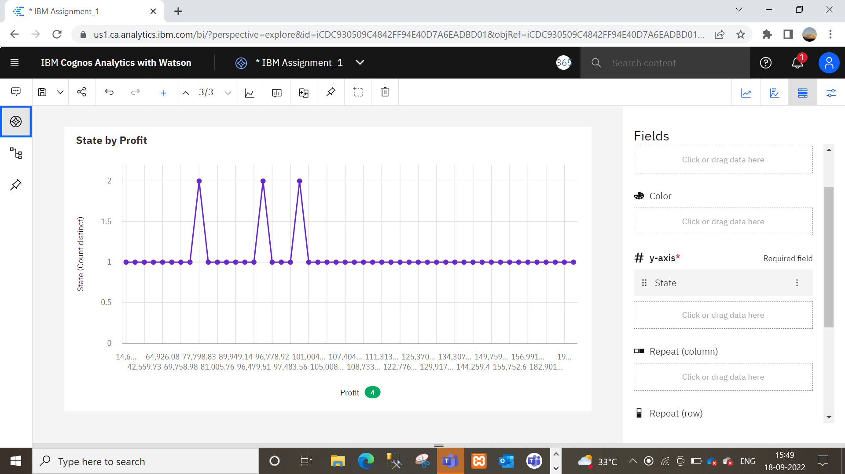



Profit is more in New York.

Link: https://us1.ca.analytics.ibm.com/bi/?perspective=explore&pathRef=.my_folders%2FIBM%2BAssignment%2FIBM%2BAssignment_1&subView=model000001834ffb92fb_00000004